PRESS RELEASE 03 FEBRUARY 2022 - ANNOUNCEMENT

ACTORS TOURING COMPANY ANNOUNCES NEW TRUSTEES

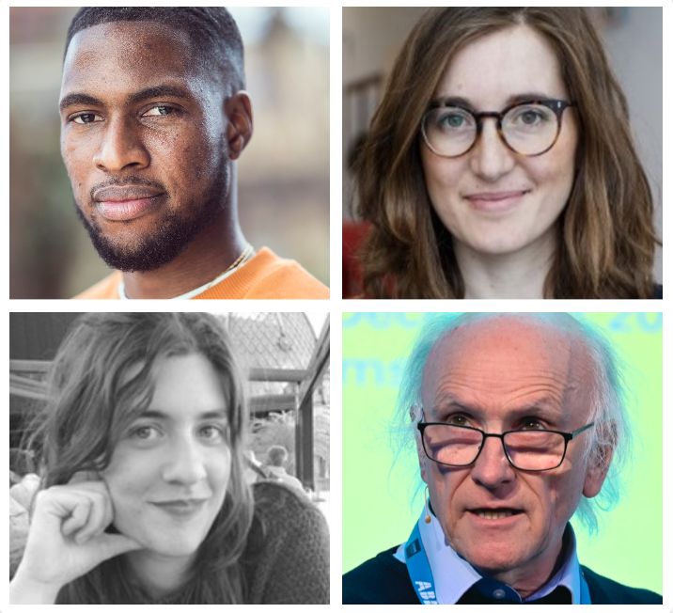

ACTORS TOURING COMPANY, the UK’s leading producer of international plays strengthens its board and announces the appointment of four new trustees – Steven Kavuma, Margherita Laera, Allegra Nespoli and Nick Tyler.

They join the current trustees Geraldine Brodie, Sudha Bhuchar, Maria M Delgado, Alan Evans, Sarah Grochala, Sanpreet Janjua and Vincent Keaveny, at a time when the organisation embarks on its first major UK tour (10 weeks across 9 venues) of award-winning Australian playwright Michele Lee’s Rice, following an almost two-year pandemic-enforced hiatus.

The new trustees bring a raft of professional skills and lived experience which will further strengthen ATC’s reputation as the leading commissioner of plays by writers from global cultures within the UK and as a producer of international plays. ATC’s latest commission Family Tree, written by Mojisola Adebayo, was recently announced the winner of the prestigious Alfred Fagon 2021 Award.

Geraldine Brodie, ATC’s chair said: “Since the pandemic, ATC has collaborated with 5 peer theatre companies to commission 18 writers, put 11 performances online, sent letters of hope to 600 participants worldwide, and produced two live productions: one UK premiere and one world premiere employing 60 freelance workers. There is no doubt that with the addition of Steven Kavuma, Margherita Laera, Allegra Nespoli and Nick Tyler, our board will be in an even stronger position to support ATC’s vision to champion unheard voices and produce brave theatre that nourishes hearts and minds at a vital time when our fragile world needs to feel connected more than ever.”

Matthew Xia, ATC’s award-winning Artistic Director added: “It’s been a tumultuous time for everyone in theatre but I feel the breadth of experience this board brings will help us to continue with renewed focus and energy our mission to commission and produce plays which challenge and inspire and highlight the shared humanity across continents.”

Writer and Director Steven Kavuma comments: “I love ATC’s work and I’m really excited to be joining such an outward facing, forward facing and truly representative theatre company under the leadership of artistic director Matthew Xia. I hope my input will help to support its ambition to further connect with communities beyond London, touring important plays by exciting and dynamic writers from both within the UK and internationally.“

Margherita Laera added: “As a scholar of theatre translation and an advocate for the value of staging international plays, I am thrilled that, under Matthew Xia’s artistic directorship, the organisation champions the work of contemporary women playwrights of Black and Global Majority heritage from around the world, who are still underrepresented on stage. The theatre is a place where we learn to honour and respect the stories of others, and where we learn to care about them, no matter which part of the planet they take place in. I look forward to supporting ATC in bringing challenging, timely and moving new work to the next generations of local and global audiences.”

Theatre and live events producer Allegra Nespoli said: “I am honoured to be joining the board of ATC, whose work providing a platform to underrepresented voices is vital. I have always admired ATC’s ethos of exploring cross-cultural perspectives and bringing them to British audiences, and I am very excited to play a part in its mission.”

Professor Nick Tyler, who is a leading academic in the field of performance arts and the built environment, added: “This is a period of great challenge for the theatre world and ATC's special place in it in particular. I am looking forward to working with the company in the transition from the present challenges towards an exciting future."

Actors Touring Company is a National Portfolio Organisation and is funded by the Arts Council. Its signature productions include The Brothers Size by Tarell Alvin McCraney, due to be revived on Broadway in 2022, Amsterdam by Maya Arad Yasur in 2019, the debut of ATC’s Artistic Director Matthew Xia. Dear Tomorrow, by 13 playwrights from around the globe during lockdown (online with Northern Stage) and 2021 Alfred Fagon Award winning Family Tree by Mojisola Adebayo in association with the Young Vic, which premiered as an outdoor work in progress at the Greenwich & Docklands Festival in August 2021.

The 2022 UK tour of Michele Lee’s Rice which opens this month, is produced by Actors Touring Company and the Orange Tree Theatre, in association with Theatre Royal Plymouth.

Press enquiries to Diana Whitehead: diana@fourthwallpr.co.uk, Tel: 07939 149887

-ENDS-
Notes to Editors

ABOUT STEVEN KAVUMA
Throughout his career, writer and director Steven Kavuma has passionately advocated for change within the theatre industry. Kavuma trained at the Royal Central School of Speech and Drama.

Recently, he was appointed Course Leader of Foundation Acting at ArtsEd and featured in The Stage 100 list (2020) as one of the most influential people in theatre. He is the co-founder of Uproot Productions, is a socially driven cross-arts production company and co-founder of Diversity School Initiative, a campaign initiative addressing under-representation / diversity in UK drama schools.

Directing credits include: Romeo and Juliet by William Shakespeare, Globe Theatre / Royal Conservatoire of Scotland; An Octoroon (Radio Remix) by Branden Jacobs-Jenkins, UAL; Blue/Orange by Joe Penhall, ALRA; Teleportation by Ronkẹ Adékoluẹjo, Bunker Theatre and BOYS, devised by the company, Dalston Eastern Curve Garden. Associate / Assistant director credits include: Holes by Louis Sachar, directed by Adam Penford (Touring); Still No Idea, Royal Court Theatre, directed by Lee Simpson; An Octoroon, National Theatre & Orange Tree Theatre, directed by Ned Bennett.

ABOUT MARGHERITA LAERA
Margherita Laera is a Senior Lecturer in Drama and Theatre at the University of Kent in Canterbury, where she is also co-Director of the European Theatre Research Network and a member of the Leadership Team for the Migration and Movement Signature Research Theme. She is the author of Playwriting Europe: Dramaturgy, Translation and the Fabulamundi Project (Routledge Focus, 2022); Theatre & Translation (Red Globe Press, 2019) and Reaching Athens: Community, Democracy and Other Mythologies in Adaptations of Greek Tragedy (Peter Lang, 2013); and editor of Theatre and Adaptation: Return, Rewrite, Repeat (Bloomsbury, 2014).

Margherita also works as a theatre translator from and into Italian and English. In 2018, she won the Theatre and Performance Research Association's Early Career Research Prize for her work on theatre translation.

ABOUT ALLEGRA NESPOLI
Allegra Nespoli is a theatre and live events producer. Over the last ten years, she has worked in a range of leading arts organisations including Raindance Film Festival, Edinburgh Festival Fringe Society, the Roundhouse and The Old Vic Theatre. She is currently Producer for Curious Monkey, a theatre company of sanctuary based in Newcastle who works with people of refugee background and young people with experience of the care system.

Allegra is also an independent producer. Her theatre company 1989 Productions focuses on producing socially and politically engaged work that gives a platform to emerging artists and marginalised voices. She is honoured to be joining ATC.

ABOUT NICK TYLER
Professor Nick Tyler CBE FREng is the Chadwick Professor of Civil Engineering at UCL and the Director of the UCL Centre for Transport Studies. Nick combines highly diverse fields in his research, from civil/transport engineering and architecture to neuroscience, psychology, physiology, ophthalmology, audiology, orthopaedics, lighting, olfaction, haptics, sound, and acoustics.

He has a particular interest in performance arts and how the built environment enhances or detracts from these for either performers or audiences. To do this he has created a £50M massive (44,000m3) multiscale multisensorial Person-Environment-Activity Research Laboratory (PEARL) to allow him and his team to study the interactions of environments, people and their activities at life-scale – as a means of ensuring that we design and construct environments that are accessible and enjoyable for everyone.

He is a co-investigator of the UCL Ecological Brain Doctoral Training Programme and the RELIEF Centre, where he is working on social space in refugee camps in Beirut. Apart from research into access to trains and platforms for London Underground and London Buses, issues around hearing, seeing in urban environments, and navigation for people with dementia. Nick is a Fellow of the Royal Academy of Engineering, the Institution of Civil Engineers, the Chartered Institution of Highways and Transportation, and the Royal Society of Arts, and was appointed CBE in 2011

ABOUT ACTORS TOURING COMPANY
Actors Touring Company (ATC) is the UK’s leading theatre producer of international plays. We create dialogue between Britain and the rest of the world – and between the intersecting cultures within nations. We are one of the only UK theatre companies committed to producing plays that come from beyond our shores.

We are equally passionate about amplifying the voice of the ‘outsider within’, and the cross-cultural communities at the heart of our nation. We are a leading commissioner of plays by writers from the global cultures within the UK.

Founded in 1980, ATC is a company that is continually evolving and seeking to reflect the UK of the 21st century in our work and the creative practitioners and communities we collaborate with and serve.

We create, sustain and develop a dialogue between global artists and UK audiences. In the last decade, we have produced plays from Australia, Norway, Germany, Israel, and the US - bringing international voices to audiences across the UK, from Glasgow to Plymouth and internationally, from Helsinki to Hong Kong.

Signature productions include:
- The Brothers Size by Tarell Alvin McCraney, directed by Bijan Sheibani, due to be revived on Broadway next year
- Amsterdam by Maya Arad Yasur, the ATC debut of Artistic Director Matthew Xia, originally made in 2019, then streamed during 2020, in coproduction with Theatre Royal Plymouth and the Orange Tree Theatre
- Dear Tomorrow, by 13 playwrights from around the globe, letters for performance at home during lockdown (including a digital version with Northern Stage)
- WINNER of the Alfred Fagon Awards 2021, Family Tree by Mojisola Adebayo, in association with the Young Vic, premiered as an outdoor work-in-progress at the Greenwich & Docklands International Festival (GDIF) in August 2021.

ABOUT MATTHEW XIA
Matthew Xia, one of the busiest and most exciting directors in the UK, was appointed Artistic Director of Actors Touring Company in 2019. He is a former Associate Artistic Director of Royal Exchange Theatre, Manchester; Director in Residence at Liverpool Everyman & Playhouse; and Associate Director of Theatre Royal Stratford East. He is currently an Associate Artist at Nottingham Playhouse. Matthew is a founding member of Act for Change, a trustee of Artistic Directors of the Future and Cardboard Citizens. His productions include Shebeen (Nottingham Playhouse, touring); Blue/Orange (Young Vic) and Sizwe Banze is Dead (Young Vic, touring) and The Wiz (Hope Mill Theatre). Matthew also commissioned and directed Mojisola Adebayo’s 2021 Alfred Fagon Award-winning play Family Tree – an outdoor Work-in-Progress show which premiered at the GDIF in 2021.

